**Pratice Making API Access Practice Through WOKWI Simulation**

*Damar Lintang Priyatama*

*Fakultas Vokasi, Universitas Brawijaya*

*Email:* [*damarpriya138@gmail.com*](mailto:damarpriya138@gmail.com)

**Abstract**

This project demonstrates how to simulate and interact with an IoT device using Wokwi Simulator, an ESP32 microcontroller, and a Laravel API. The goal is to send sensor data (temperature and humidity) from a DHT22 sensor to a backend API developed using Laravel 11 and expose it through Ngrok for external access. The setup involves simulating an IoT device on the Wokwi platform, connecting it to a Wi-Fi network, and periodically sending HTTP POST requests to store sensor data in a MySQL database. This project emphasizes the practical use of IoT simulations for cloud-based applications and real-time data collection using standard protocols like HTTP.

*Keywords—* *IoT, laravel API, DHT22 Sensor, MySQL, PlatformIO.*

**1. Introduction**

**1.1 Background**

The Internet of Things (IoT) enables devices to collect and exchange data, which is crucial for modern automation and smart systems. Laravel, a PHP framework, offers a robust solution to create APIs for managing and processing data, while Ngrok provides an easy way to expose local servers to the internet. In this context, simulating an ESP32 IoT device with a DHT22 temperature and humidity sensor via Wokwi provides a cost-effective solution for testing and prototyping IoT applications without requiring physical hardware. This project focuses on establishing a connection between the IoT device and the backend API to send sensor data and store it in a database.

**1.2 Purpose Experience**  
The purpose of this project is to gain hands-on experience in building and testing an IoT application that involves a real-time data pipeline between an IoT device (ESP32) and a Laravel-based API. The experience aims to strengthen the understanding of IoT architecture, cloud API integration, and real-time data exchange between devices and servers.

**2. Methodology**

**2.1 Tools & Materials**

-Laptop Asus

-Vscode

-laravel 11

-Postman

-Xampp

-Ngrok

-Composer

-Wokwi ESP32

**2.2 Implementation Steps**

* Steps to Wifi Connect

-Start the Laravel API with the following command to ensure it is accessible from any IP address:

php artisan serve --host=0.0.0.0 --port=8080

-Create a new Wokwi Simulator project in PlatformIO.

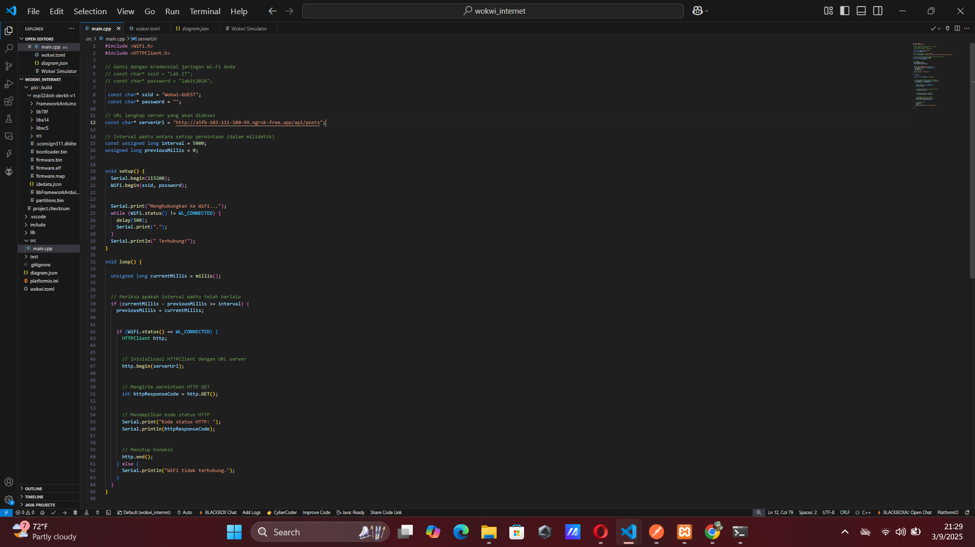-Write the firmware (main.cpp) for the ESP32 to connect to Wi-Fi and send HTTP GET requests to the Laravel API.

-Use Ngrok to expose the local Laravel server to the internet. Run the command:

ngrok http --scheme=http 8080

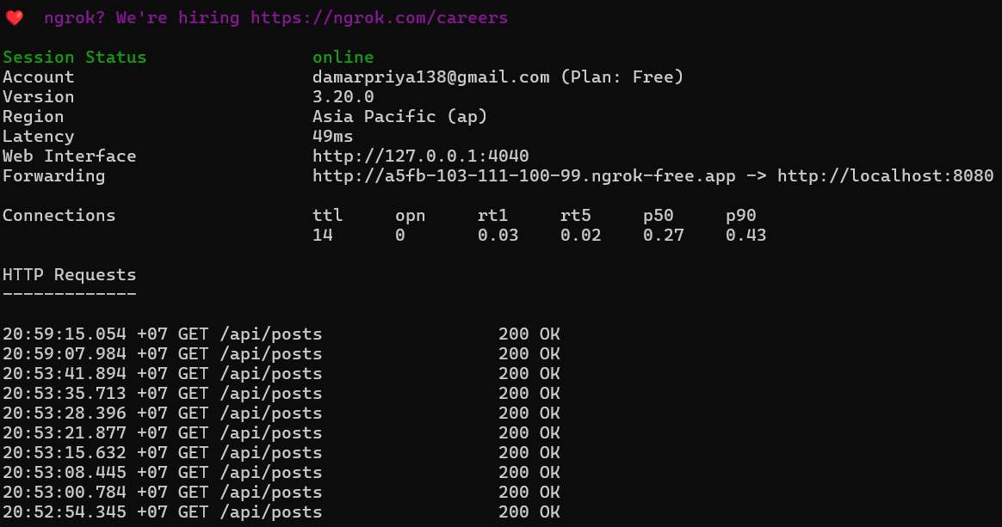

-Update the main.cpp to periodically send HTTP GET requests to the Ngrok URL.

-The code connects the ESP32 to Wi-Fi and sends requests to the API every 5 seconds.

* Steps to Sensor Suhu

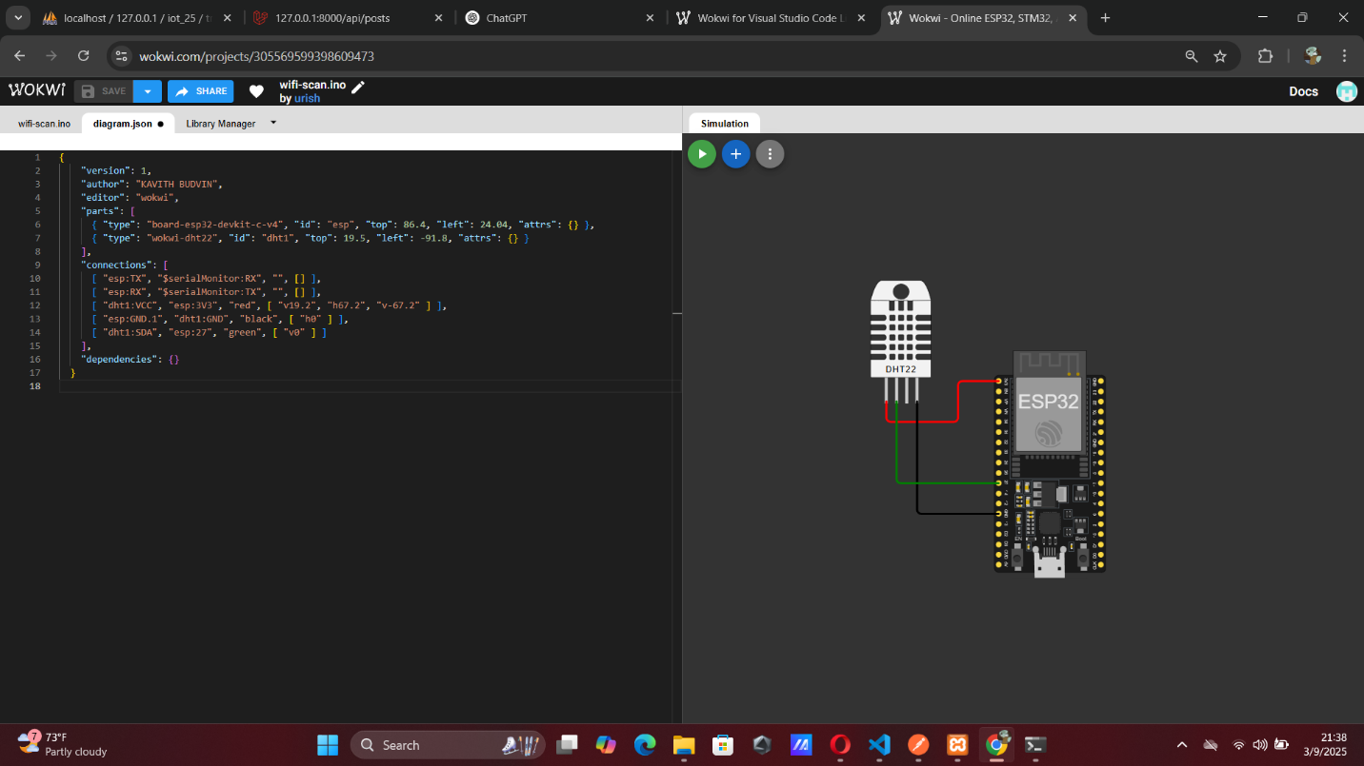-Build and run the Wokwi Simulator to simulate the ESP32 device.

-Attach a DHT22 sensor to the ESP32 (simulated in Wokwi) and modify the code to read temperature and humidity.

-Send the sensor data to the API using an HTTP POST request every 5 seconds.

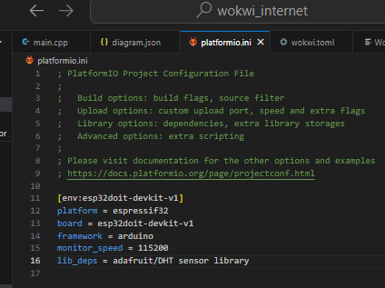-Update the platformio.ini file to include DHT22 sensor libraries and monitor serial output for data sent to the API.

-Modify main.cpp to collect data from the sensor and send it in the payload of the POST request.

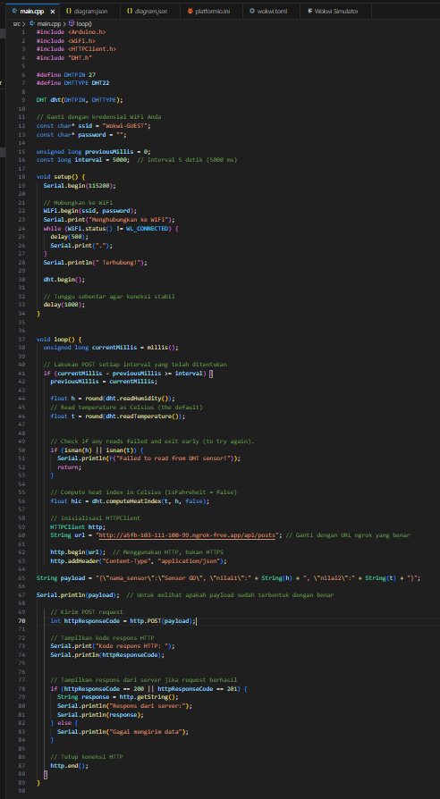

-Build the simulation with Wokwi and run it.

-Ensure the ESP32 successfully reads sensor data and sends it to the API.

-Check the MySQL database to verify that the sensor data is stored correctly, once the simulation runs successfully, ensure data appears in the database as it is sent from the simulated ESP32 to the Laravel API.

**3. Results and Discussion**

**3.1 Experimental Results**

* 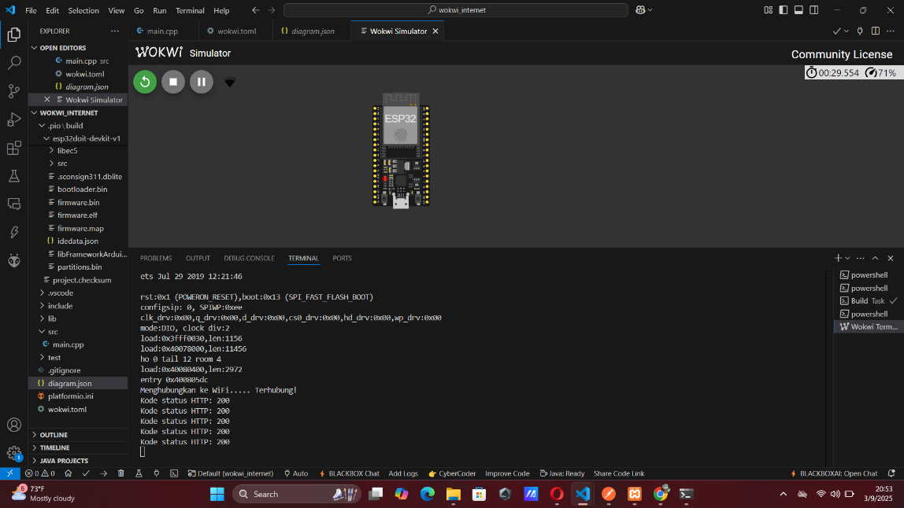**Result WIFI Wokwi-GUEST**
* 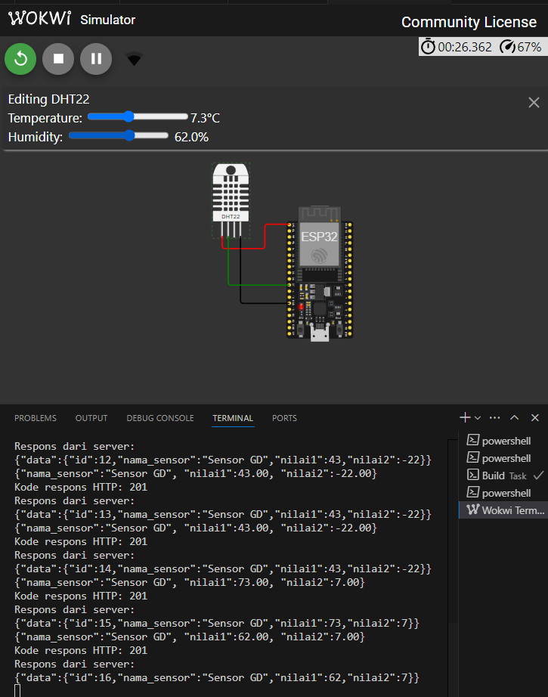**Result Sensor suhu with API**
* **data API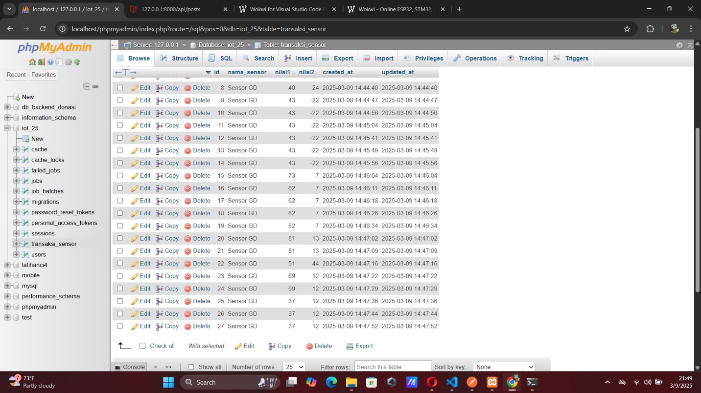 from sensor suhu**